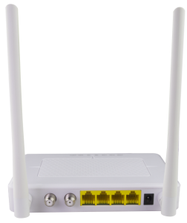
New EOC Slave with 4FE and WIFI - EOC1121R4WL-R410

How to add new slave type in EOC Master WEB management
The problem is that your EOC master do not recognize this new slaves automatically, you need to add this new slave type in to System - Slave type table. Please add new type as shown in picture bellow - ID 3 is the new slave type, please use user HFID identifier of this new WiFi slaves version- A7414V01. Slave Class is SW+WIFI and Port Number is 3 (STB1,STB2,WIFI and LAN ports as one port number 3)
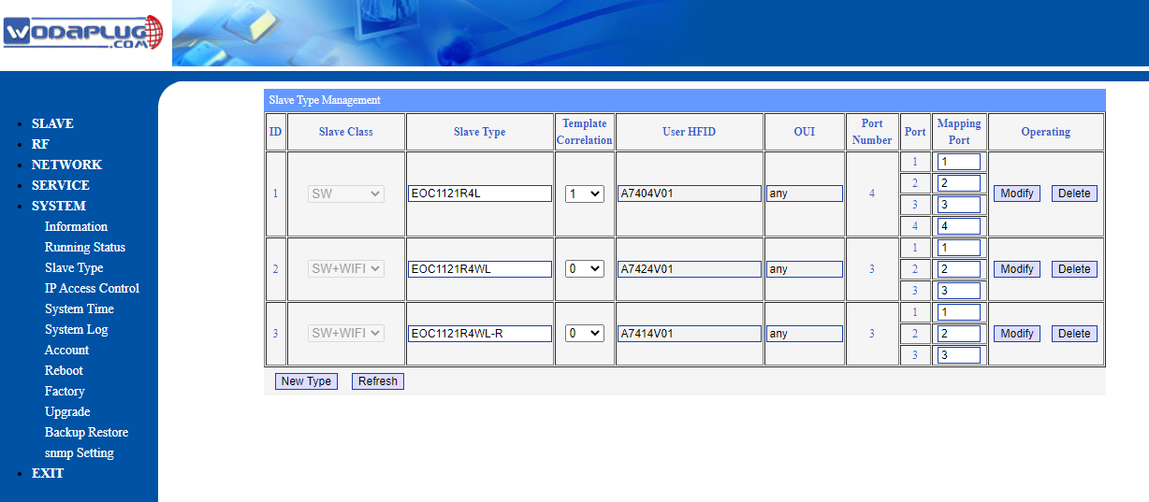

Then new slaves connected to master will be recognized and you can configure them same way as before. But if you connected a new slave to a master before creating this new type entry in slave type table, then your slave was recognized as UNKNOWN and you have to go to Slave - Authorization table and change slave type to this new slave type newly created manually - please see picture bellow :

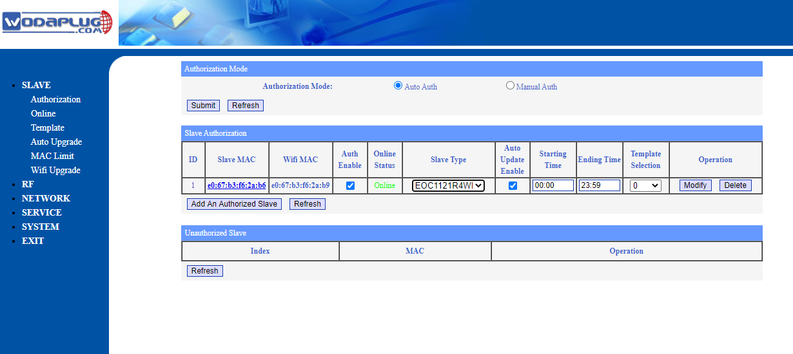

After this you are able to configure new WiFI slaves same way as before and now you can change default WAN
configuration from Route to Bridge :

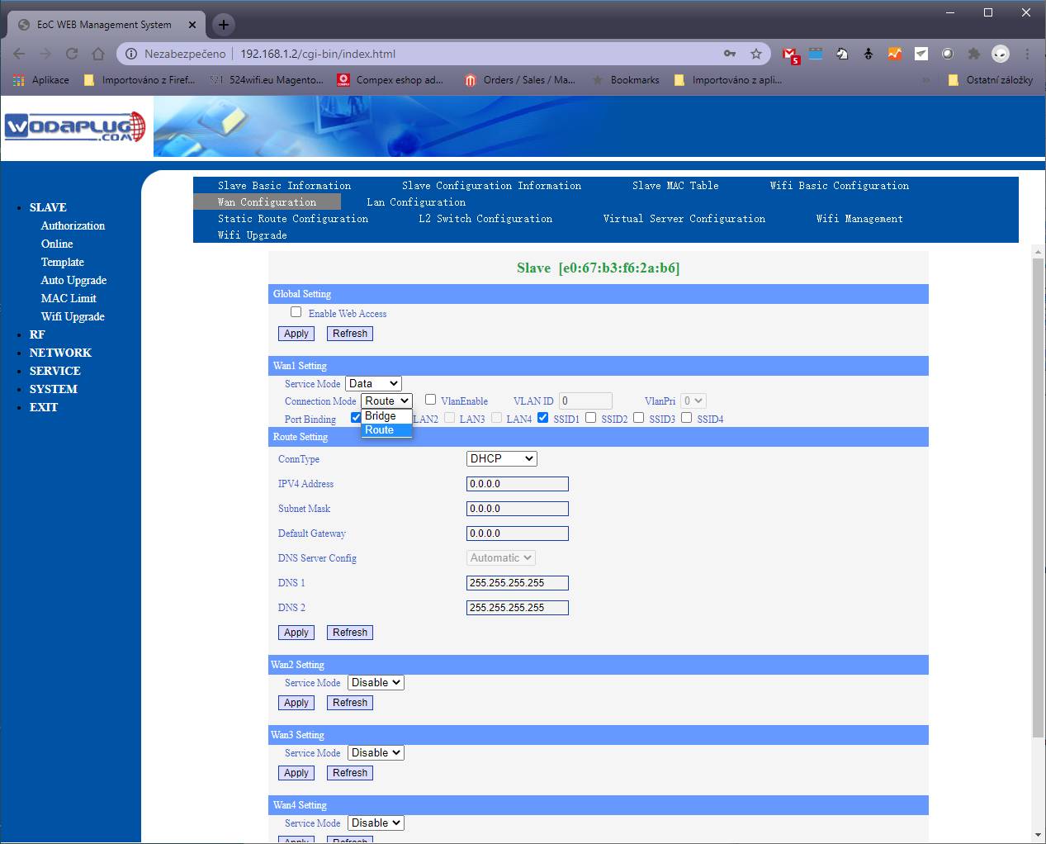
- Overview
EOC1121R4WL-R410 modem is the EOC slave based on HomePlug AV solution for Ethernet access over coax. It works together with EOC master which is based on HomePlug AV solution as well to construct a two-layer Ethernet data transmission channel on CATV coax cable, provide the Ethernet access service based on the existing coax cable networking.
EOC1121R4WL-R410 series is based on the Mstar chipset solution (510CE chip)，with high anti jamming capability OFDM technology. The 7.5-65MHz low frequency band is used for EOC signals. Built in high isolation filter as CATV RF and EOC signal mixer, the EOC signal and CATV signal in 87Mhz~1Ghz can run on one cable without interference. The PHY Layer speed is 600Mbps,the MAC Layer throughput is up to 320Mpbs.
EOC1121R4WL-R410 series WIFI is based on the MTK chipset solution. It meets 802.11 b/g/n technical standards. It has two external antenna, and can support 2.4GHz wireless signal. It has the characteristics of strong penetrating power and wide coverage. It can provide users with more efficient data transmission security.

